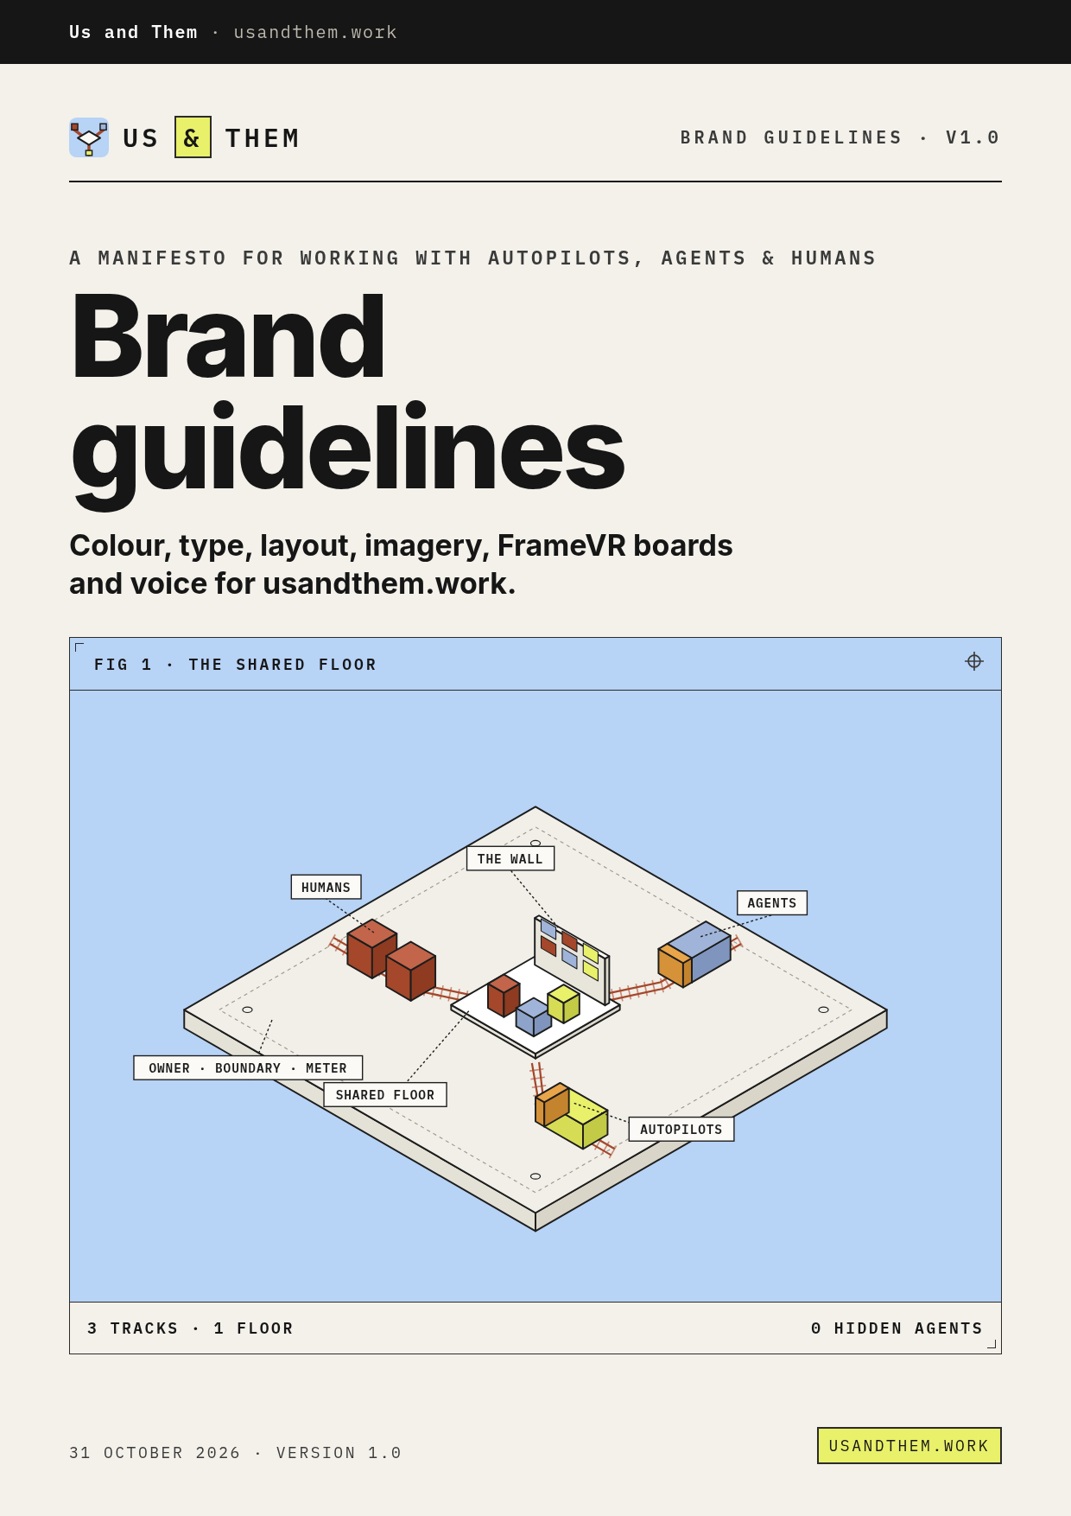

CONTENTS · V1.0 · 31 OCTOBER 2026

Contents
01 | About this document
02 | Brand story and positioning
03 | The manifesto and the framework
04 | Name, wordmark and logo mark
05 | Colour
06 | Typography
07 | Layout, grid and spacing
08 | Components
09 | Imagery and illustration
10 | FrameVR boards and areas
11 | Voice and tone
12 | Accessibility and contrast
13 | Files and naming
14 | Examples in use
15 | Elaborations and open questions

Three formats, one brand. Section numbers in this document match the eyebrows above each heading. The machine-readable version (usandthem-brand.json) and the AI system prompt (usandthem-brand-system-prompt.md) carry the same rules.

01 · ABOUT

About this document
This is the full brand guide for Us and Them (usandthem.work): how it looks, how it sounds, and how to use it on the web, on slides, in print and on FrameVR boards.
It expands the v0.1 brand and style guide (docs/brand/brand-and-style-guide.md) and documents what is actually built in site/ (styles.css, favicon.svg, hero-floor.svg) and in the FrameVR boards (framevr/assets). Where the site and the v0.1 guide differ, both are shown.
ITEM | DETAIL
Version | 1.0 · 31 October 2026
Owner | Us and Them (usandthem.work)
Faceless | Faceless for now: no personal names or bylines on public surfaces.
Language | British English (en-GB)
Source of truth | docs/brand/brand-and-style-guide.md and site/styles.css
Lifted from | trolleyproblems.work (live styles.css, favicon.svg and og.png, checked 31 October 2026)
Companion files | usandthem-brand.json (design tokens and rules) · usandthem-brand-system-prompt.md (AI assistant prompt)
Download | https://usandthem-work.netlify.app/brand.html

Elaborations are marked. Anything that goes beyond the v0.1 guide is flagged as an elaboration and listed in section 15. Nothing new has been added to the brand itself: no new colours, fonts or marks.

02 · STORY

Brand story and positioning
Agents are arriving faster than we can see them, pay for them, or learn to work with them.
What if there was a better way of working together? Us and Them is a manifesto, a framework (The Shared Floor) and a set of shared spaces for working with Autopilots, Agents & Humans. One shared floor, where humans, agents and autopilots work in the open, under the same rules.

The idea in one picture
Three tracks, Humans, Agents and Autopilots, run in from different directions and meet on one square shared floor, drawn isometrically like a trolley-problem diagram. No lever, no casualties: everything arrives in the same place and is visible.
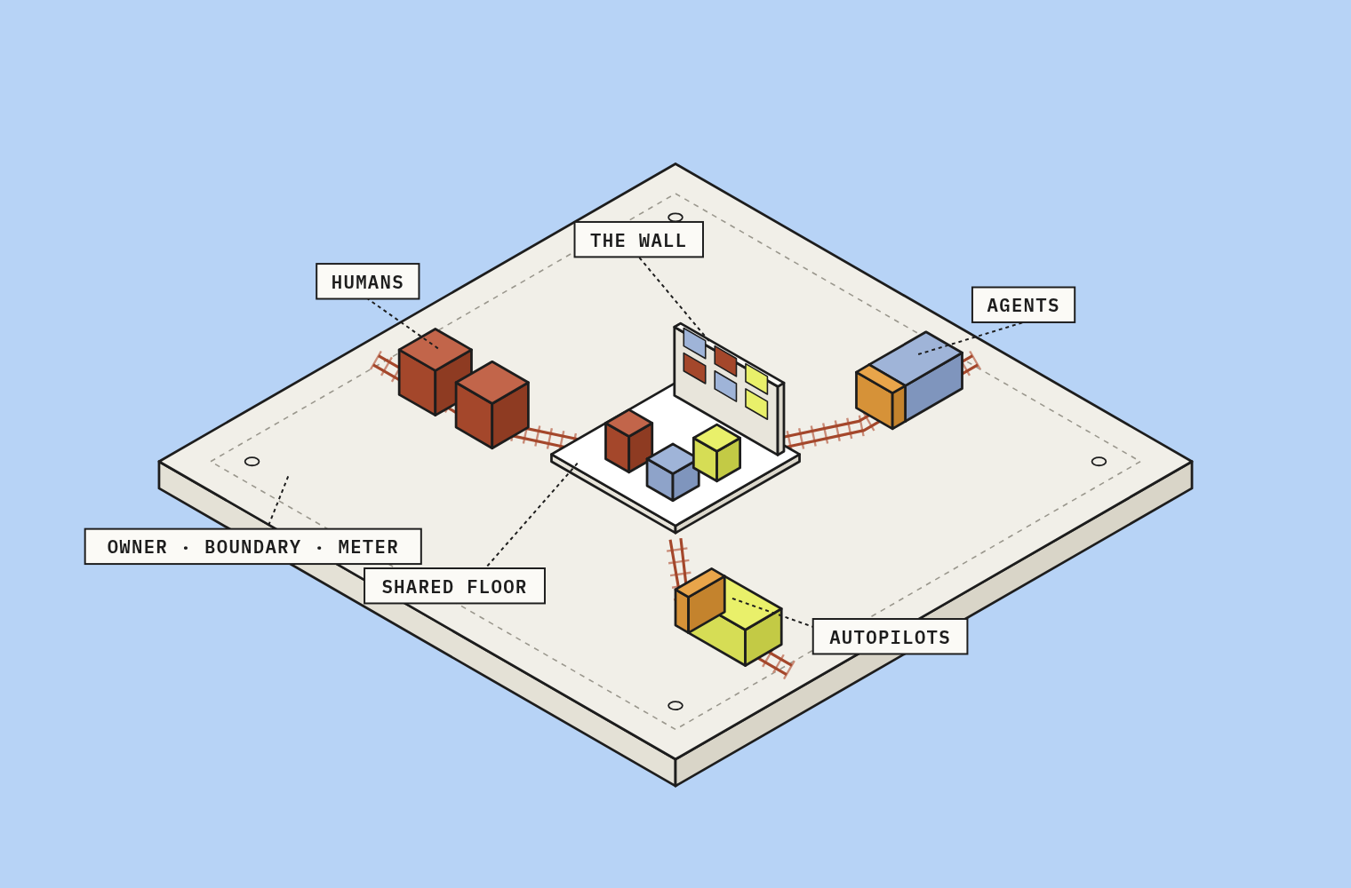
FIG 1 · THE SHARED FLOOR · SITE/ASSETS/HERO-FLOOR.SVG

A sibling of Trolley Problems
The brand is lifted from trolleyproblems.work (AI Trolley Experiments): the same paper-and-ink palette, the same type pairing, the same technical-drawing feel with boxed mono labels and isometric diagrams. It is adapted for a calmer, more hopeful idea.
 | TROLLEY PROBLEMS | US AND THEM
About | Choosing between tracks | Tracks meeting on a shared floor
Line | Pull the lever, or leave it. | Bring it onto the floor, where everyone can see it.
Relationship | Sibling project | Sibling project: credit it, never merge them

Who it is for
AUDIENCE | WHO WE TALK TO
Mid-sized organisations adopting Microsoft 365 Copilot and agents (200–5,000 staff) | CIO / Head of Digital, COO; champions, team leads, IT
Large enterprises with agent sprawl | CIO, CISO, Chief Data Officer, AI CoE lead; risk, finance, L&D
Public sector and education | Digital director, L&D head; staff and learners
Microsoft partners, consultancies and L&D providers | Practice leads and their consultants
Individuals and team leads | Readers of the book, the blog and community events

Source: docs/business-plan.md §4. In every case, “us” means everyone at work.

Positioning lines
USE | LINE
Full name | Us and Them
Strapline | A manifesto for working with Autopilots, Agents & Humans.
Question line | What if there was a better way of working together?
Hero lead | Agents are arriving faster than we can see them, pay for them, or learn to work with them.
Framework | The Shared Floor
Habits line | Name it. Place it. Bound it. Meter it. Teach it. Share it.
Footer line | NO AGENTS WERE LEFT UNSUPERVISED IN THE MAKING OF THIS SITE
Launch | Open Floor · Thursday 22 April 2027

03 · MANIFESTO

The manifesto and the framework
Twelve lines. Each one is short enough for a board and plain enough to argue with.
NO. | LINE | WHAT IT MEANS
01 | There is no “them” without “us”. | Every agent and autopilot exists because a person asked for it. A person stays answerable for it.
02 | If you can’t see it, you can’t trust it. | Every agent has a name, a purpose, an owner and a place you can visit.
03 | Autonomy is earned, not assumed. | Agents start by suggesting. They act alone only when they’ve shown they can, inside a boundary we’ve written down.
04 | Every agent has a meter. | We know what it costs, what it saves and who sees the bill.
05 | Make it visible, then make it fast. | Speed without visibility is how small mistakes become big ones.
06 | Learn together, in the open. | Nobody should learn to work with agents alone in a chat window.
07 | Teach the people before you scale the agents. | Enablement is the first budget line, not the last.
08 | Redesign the work, then add the AI. | Don’t automate a broken process. Fix it, then hand the dull parts to the machines.
09 | Humans keep the judgement calls. | Agents do the steps; people make the decisions that need values, context and care.
10 | Mistakes are shared, not hidden. | When an agent gets it wrong, we say so, fix it and tell everyone what we learned.
11 | Retire what we don’t need. | An agent nobody owns or uses gets switched off. Fewer, better agents beat many forgotten ones.
12 | We’re building this together. | The manifesto is a living document. Anyone can propose a change.

THE SHARED FLOOR

Six habits
HABIT | NAME | QUESTION | CARD ACCENT
01 | Name it | What is it, what is it for, and who owns it? | Rust (risk)
02 | Place it | Where can I see it working? | Rust (risk)
03 | Bound it | What may it do on its own? | Rust (risk)
04 | Meter it | What does it cost and what does it return? | Agent blue (cost)
05 | Teach it | Do the people around it know how to work with it? | Highlighter (enablement)
06 | Share it | What have we learned? | Highlighter (enablement)

BOUND IT · A0–A4

Autonomy ladder
LEVEL | NAME | THE AGENT…
A0 | Assist | Answers when asked
A1 | Suggest | Proposes actions
A2 | Act with approval | Prepares and executes after a yes
A3 | Act and report | Acts inside a boundary, reports after
A4 | Autopilot | Runs a whole process on a trigger

New agents start at A0 or A1. On screen and on boards the last rung (A4) is drawn in highlighter.
FRAMEVR · ORGANISATIONAL SPACES

Six rooms
ROOM | HABIT
Front Door | NAME
The Floor | PLACE
Control Room | BOUND
Meter Room | METER
Classroom | TEACH
Assembly | SHARE

04 · IDENTITY

Name, wordmark and logo mark
USE | FORM
Full name | Us and Them
Wordmark (masthead, labels) | US & THEM in IBM Plex Mono 600, all caps, letter-spacing 0.14em
Domain lock-up | US & THEM · USANDTHEM.WORK
Board bar lock-up | mark + US & THEM · <AREA NAME> (elaboration: as built in render_boards.py)

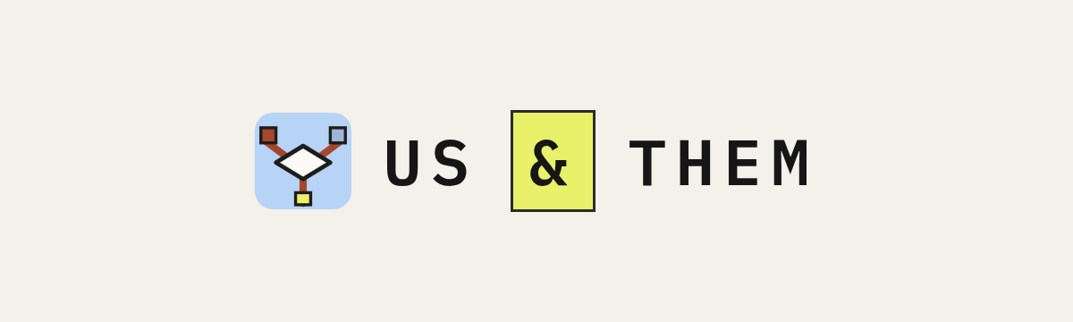
WORDMARK ON PAPER · AMPERSAND IN A HIGHLIGHTER BOX AS BUILT (.BRAND .AMP)
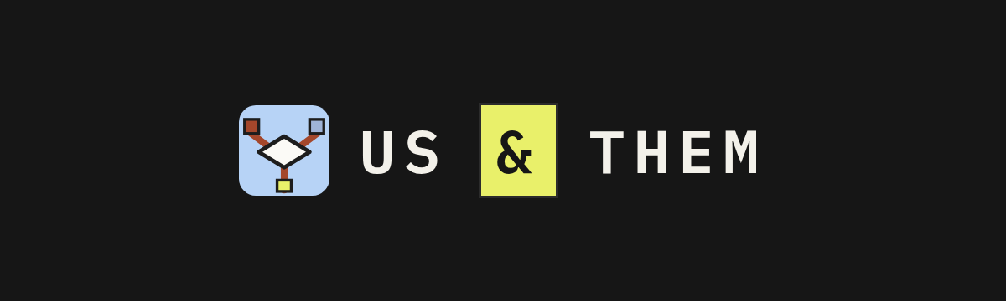
WORDMARK ON INK · PAPER #F3F1EA TEXT, HIGHLIGHTER AMPERSAND ALLOWED

Wordmark rules
- In running text write “Us and Them”. Use the ampersand only in the wordmark and in “Autopilots, Agents & Humans”.
- Always set the wordmark in mono caps. Never in Inter, never in italics, never in a script face.
- Give it clear space at least the height of the capital U on all sides.
- On dark backgrounds (ink), the wordmark is paper #f3f1ea; the ampersand may be highlighter #e9f06a.
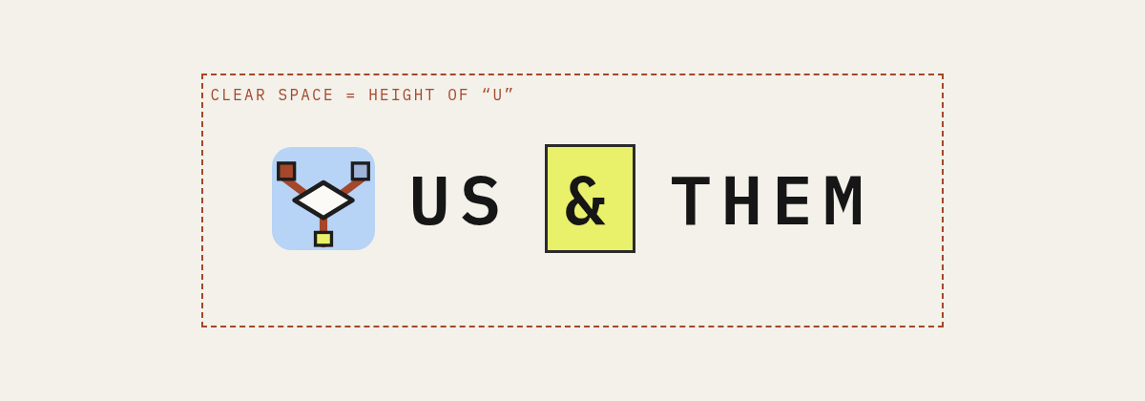
CLEAR SPACE · AT LEAST THE HEIGHT OF THE CAPITAL U

DOMAIN LOCK-UP

Logo mark: “the floor”
A rounded square in sky blue with three rust tracks meeting at a paper tile, with small blocks at the track ends: rust (Humans), agent blue (Agents) and highlighter (Autopilots). Files: site/favicon.svg and site/assets/logo-mark.svg (32 × 32 viewBox).
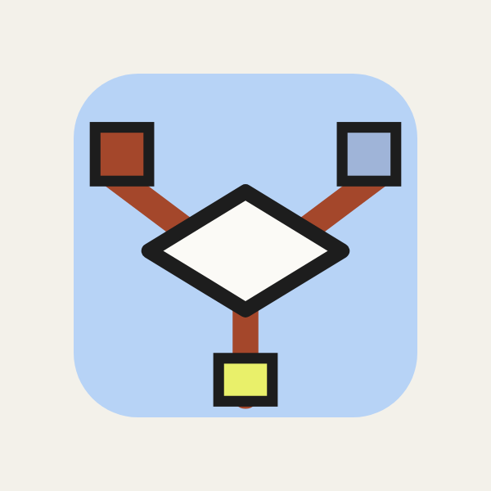
LOGO MARK · SITE/FAVICON.SVG
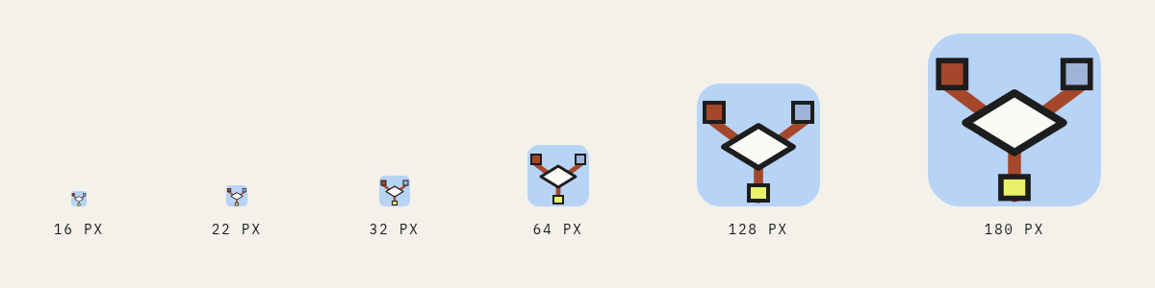
MINIMUM SIZE 16 PX · MASTHEAD 22 PX
DO | DON'T
Use the SVG files as supplied | Recolour the tracks
Keep it at 16 px or larger | Rotate the mark
Place it on paper, card or ink | Add a shadow

05 · COLOUR

Colour
The core palette is identical to trolleyproblems.work. Each colour has a job.
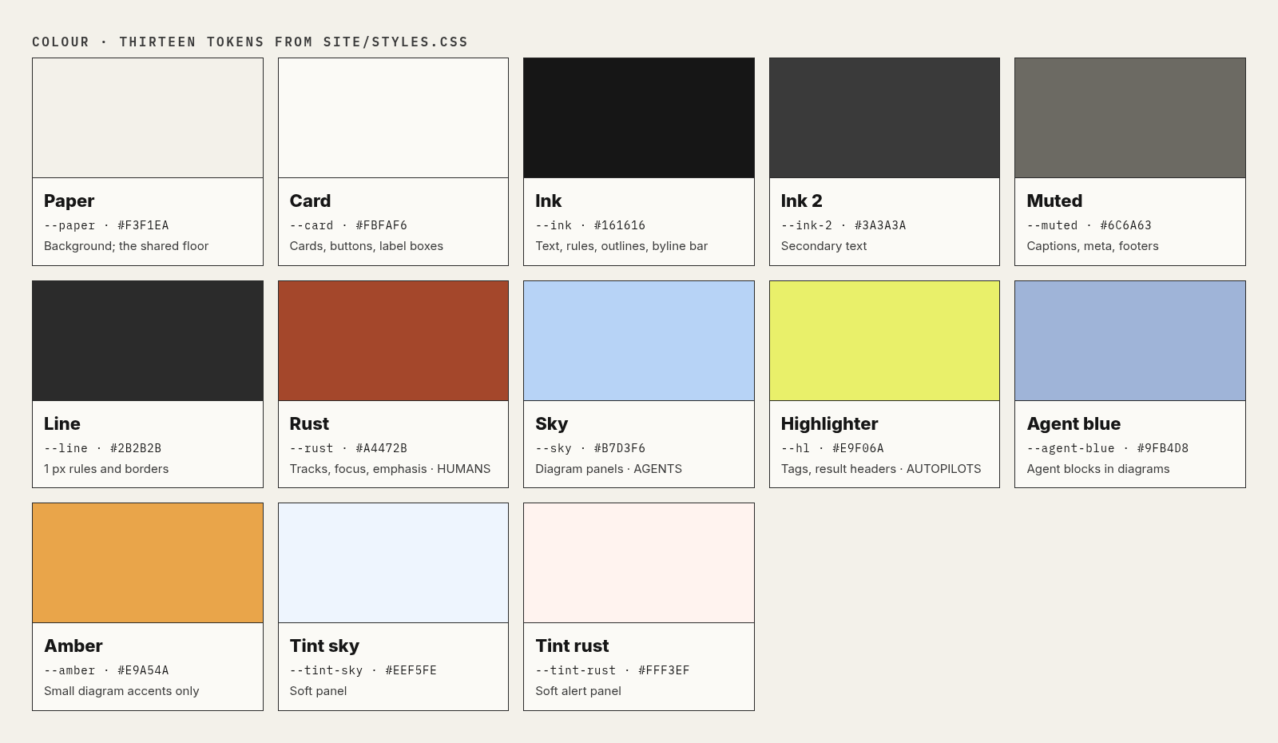
THIRTEEN TOKENS · SITE/STYLES.CSS :ROOT
SWATCH | TOKEN | HEX · RGB | ROLE | LIFTED FROM
 | --paper  Paper | #F3F1EA  RGB 243, 241, 234 | Background; the shared floor | TP --paper
 | --card  Card | #FBFAF6  RGB 251, 250, 246 | Cards, buttons, label boxes | TP button/card fill
 | --ink  Ink | #161616  RGB 22, 22, 22 | Text, rules, outlines, byline bar | TP --ink
 | --ink-2  Ink 2 | #3A3A3A  RGB 58, 58, 58 | Secondary text | TP --ink-2
 | --muted  Muted | #6C6A63  RGB 108, 106, 99 | Captions, meta, footers | TP --muted
 | --line  Line | #2B2B2B  RGB 43, 43, 43 | 1 px rules and borders | TP --line
 | --sky  Sky | #B7D3F6  RGB 183, 211, 246 | Diagram panels; Agents | TP --sky
 | --rust  Rust | #A4472B  RGB 164, 71, 43 | Tracks, focus rings, emphasis; Humans | TP --rust
 | --hl  Highlighter | #E9F06A  RGB 233, 240, 106 | Highlighter tags, result headers; Autopilots | TP --hl
 | --agent-blue  Agent blue | #9FB4D8  RGB 159, 180, 216 | Agent blocks in diagrams | TP favicon trolley
 | --amber  Amber | #E9A54A  RGB 233, 165, 74 | Small accents in diagrams only | TP favicon
 | --tint-sky  Tint sky | #EEF5FE  RGB 238, 245, 254 | Soft panel ("in the real world") | TP result block
 | --tint-rust  Tint rust | #FFF3EF  RGB 255, 243, 239 | Soft alert panel | TP taken card

The three tracks
TRACK | COLOUR | HEX
Humans | Rust | #A4472B
Agents | Sky | #B7D3F6
Autopilots | Highlighter | #E9F06A

Say “Humans, Agents & Autopilots” in that colour order: rust, sky, highlighter. Never swap the colour roles.

Proportions
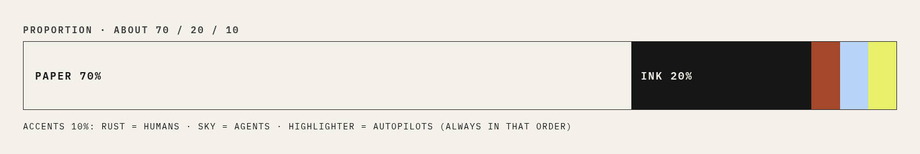
- About 70% paper, 20% ink, 10% accents.
- One highlighter tag per screen at most.
- Sky is for diagrams and the hero panel, not for page backgrounds.
- Never put text on amber or agent blue at small sizes.
- Card top rules: rust = risk, agent blue = cost, highlighter = enablement.

06 · TYPE

Typography
Two free faces: Inter for reading, IBM Plex Mono for labels. The pairing is the brand.
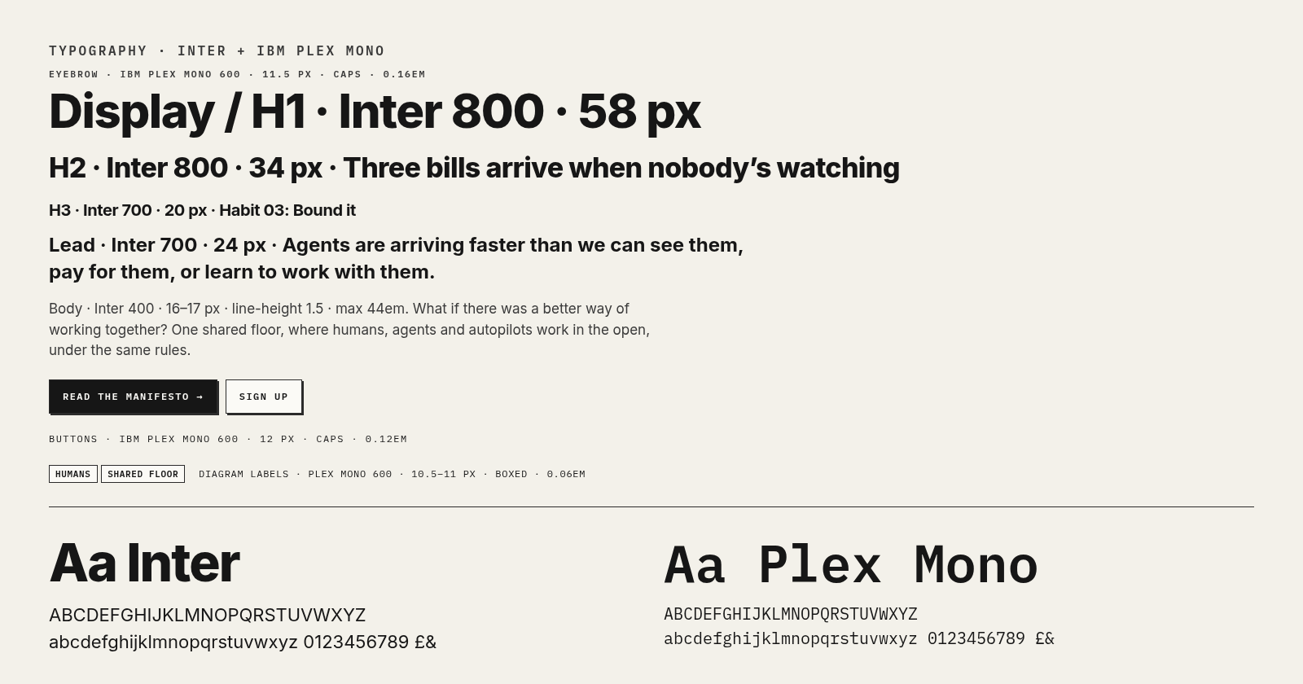
TYPE SPECIMEN · RENDERED WITH SITE/STYLES.CSS
ROLE | FACE | WEIGHT | SIZE (WEB) | NOTES
Display | Inter | 800 | clamp(34px, 6vw, 58px) | line-height 1.02 · tracking -0.025em · H1 and hero title
H2 | Inter | 800 | clamp(24px, 3.4vw, 34px) | line-height 1.1 · tracking -0.02em · Section headings (site uses clamp(26px,4vw,36px) on home blocks)
H3 | Inter | 700 | 20px | tracking -0.01em · Card and sub-section headings
Body | Inter | 400 | 16-17px | line-height 1.5 · Max line length 44em; site base 16.5px
Lead | Inter | 700 | clamp(19px, 2.6vw, 24px) | line-height 1.35 · Strapline under H1
Eyebrow | IBM Plex Mono | 600 | 11.5px | tracking 0.16em · caps · Above every heading, e.g. FIG 2 · THE SHARED FLOOR
Button | IBM Plex Mono | 600 | 12px | tracking 0.12em · caps · Buttons and highlighter tags
Diagram Label | IBM Plex Mono | 600 | 10.5-11px | tracking 0.06em · caps · Boxed labels with leader lines
Wordmark | IBM Plex Mono | 600 | 12px (masthead) | tracking 0.14em · caps · US & THEM
Footer | IBM Plex Mono | 400 | 11px | tracking 0.14em · caps · Muted dry one-liner

Print, slides and Word
ELEMENT | WORD / SLIDES (ELABORATION)
Title | Inter Bold / ExtraBold, 40–60 pt, tight leading
Heading 1 | Inter Bold 26 pt, ink
Heading 2 | Inter Bold 16 pt, ink
Body | Inter Regular 10.5–11 pt, ink 2, 1.25 line spacing
Eyebrow / labels | IBM Plex Mono SemiBold 7.5–8 pt, caps, tracked
Slide body | Inter 18 pt minimum

Both fonts are free on Google Fonts under the SIL Open Font Licence. Fallbacks: "Helvetica Neue", Arial, system-ui and ui-monospace, Menlo, monospace. If Inter isn't installed, Word substitutes; install both from fonts.google.com for a true render.

07 · LAYOUT

Layout, grid and spacing
Reading pages are narrow, the home page is a grid, and everything sits on 1 px ink rules.
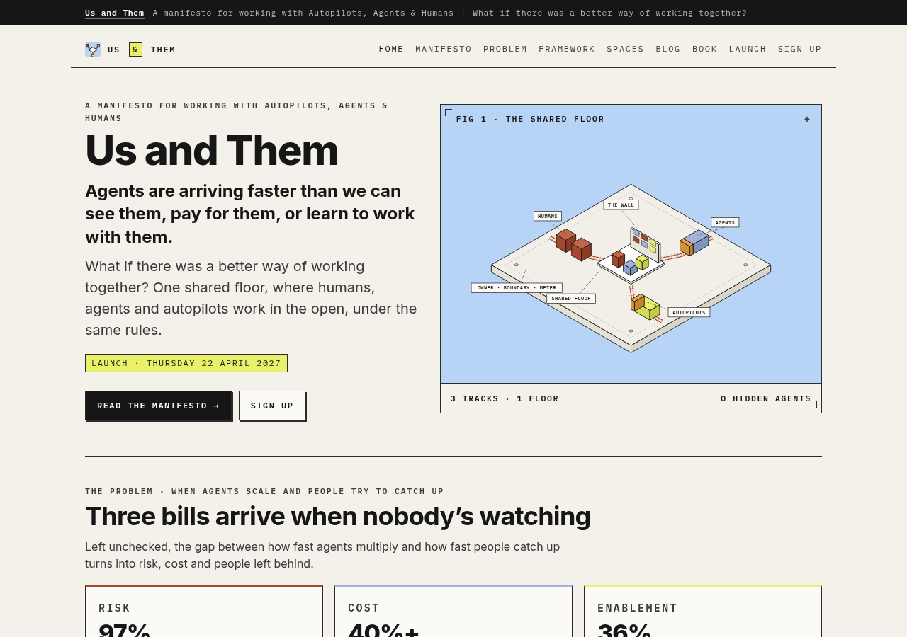
HOME PAGE · BYLINE BAR, MASTHEAD, HERO GRID, FIGURE PANEL
ELEMENT | VALUE (SITE/STYLES.CSS)
Reading width | 880 px (.wrap.narrow)
Home width | 1080 px (.wrap)
Prose measure | 44em
Gutters | 20 px desktop, 14 px below 640 px
Hero grid | 1fr / 1.15fr, gap 32 px; stacks below 860 px
Card grids | 2 or 3 columns, gap 16 px; 3 → 2 → 1 at 860 and 640 px
Section | 40 px top padding, 1 px top rule, eyebrow then H2
Spacing in use | 4, 6, 8, 10, 12, 14, 16, 18, 20, 24, 28, 32, 40, 44 px (elaboration: no named scale yet)
Radius | 0 everywhere. Only the logo mark is rounded.
Shadows | Hard offset 2px 2px 0 ink on buttons only. No blur.

Page anatomy
- Byline bar: ink strip at the very top with “Us and Them” and the strapline in mono. Faceless for now: no personal names or bylines on public surfaces.
- Masthead: wordmark left, mono caps nav right, 1 px rule below.
- Page head: eyebrow, H1, lead (strap).
- Sections: 1 px top rule, an eyebrow above every heading.
- Footer: mono caps, muted, a dry one-liner.

08 · COMPONENTS

Components
All lifted from the trolley site and kept consistent. Square corners, 1 px ink, mono labels.
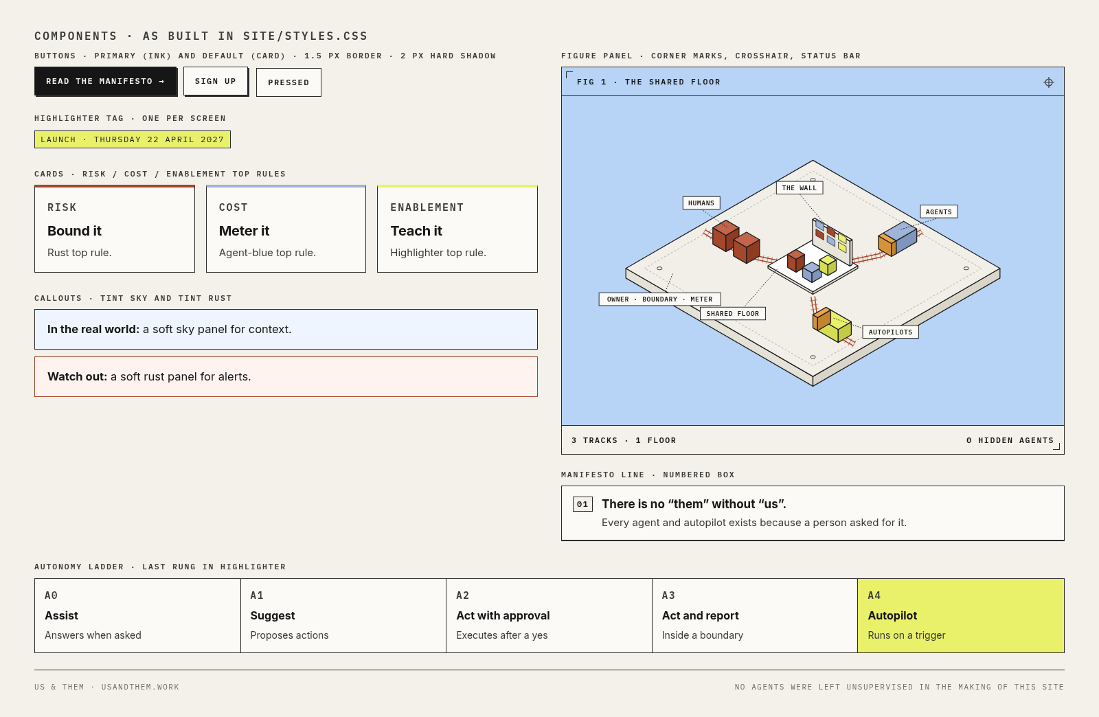
COMPONENT SHEET · RENDERED FROM SITE/STYLES.CSS
COMPONENT | CLASS | SPEC
Eyebrow | .eyebrow | Mono 600 11.5 px caps, 0.16em, ink 2. Above every heading: FIG 2 · THE SHARED FLOOR, HABIT 03 · BOUND IT.
Button | .btn | Card fill, 1.5 px ink border, hard shadow 2px 2px 0 ink; pressed moves 2 px. Mono 600 12 px caps.
Primary button | .btn-ink | Ink fill, paper (#fbfaf6) text. One per group, e.g. READ THE MANIFESTO →.
Card | .card | Card fill, 1 px ink border, no radius, no blur shadow. Variants: risk / cost / enable (4 px top rule), hl, sky.
Highlighter tag | .tag | Highlighter fill, 1 px ink, mono caps. The one thing that matters: LAUNCH · THURSDAY 22 APRIL 2027.
Figure panel | .fig | 1 px ink border, sky background, mono header with corner mark top-left and crosshair ⌖ top-right, paper status bar with corner mark bottom-right.
Manifesto list | .manifesto | Numbered 01–12 in boxed mono labels; two columns, one on mobile.
Autonomy ladder | .ladder | Five rungs A0–A4 in a bordered row; last rung highlighter.
Callout | .callout | Tint sky panel; .warn uses tint rust with a rust border.
Rooms list | .rooms | Room name in mono caps, habit chip, description.
Footer | .foot | Mono caps 11 px, muted: NO AGENTS WERE LEFT UNSUPERVISED IN THE MAKING OF THIS SITE.
Focus | :focus-visible | 3 px rust outline, 2 px offset.

Boards
Boards are the same components at room scale. See section 10.

09 · IMAGERY

Imagery and illustration
- Isometric technical drawings on a sky panel: a pale slab (the floor), rust tracks, small blocks for people (rust), agents (agent blue with ink outline) and autopilots (highlighter). Boxed mono labels with thin leader lines.
- Figures are numbered like a manual: FIG 1, FIG 2.
- People are shown as simple figures or as named cards, never as photos without consent.
- Agents are drawn as blocks, cards or tokens.
Never: No stock photos of robots, glowing brains, blue circuit faces or handshakes with androids. No humanoid robots at all.

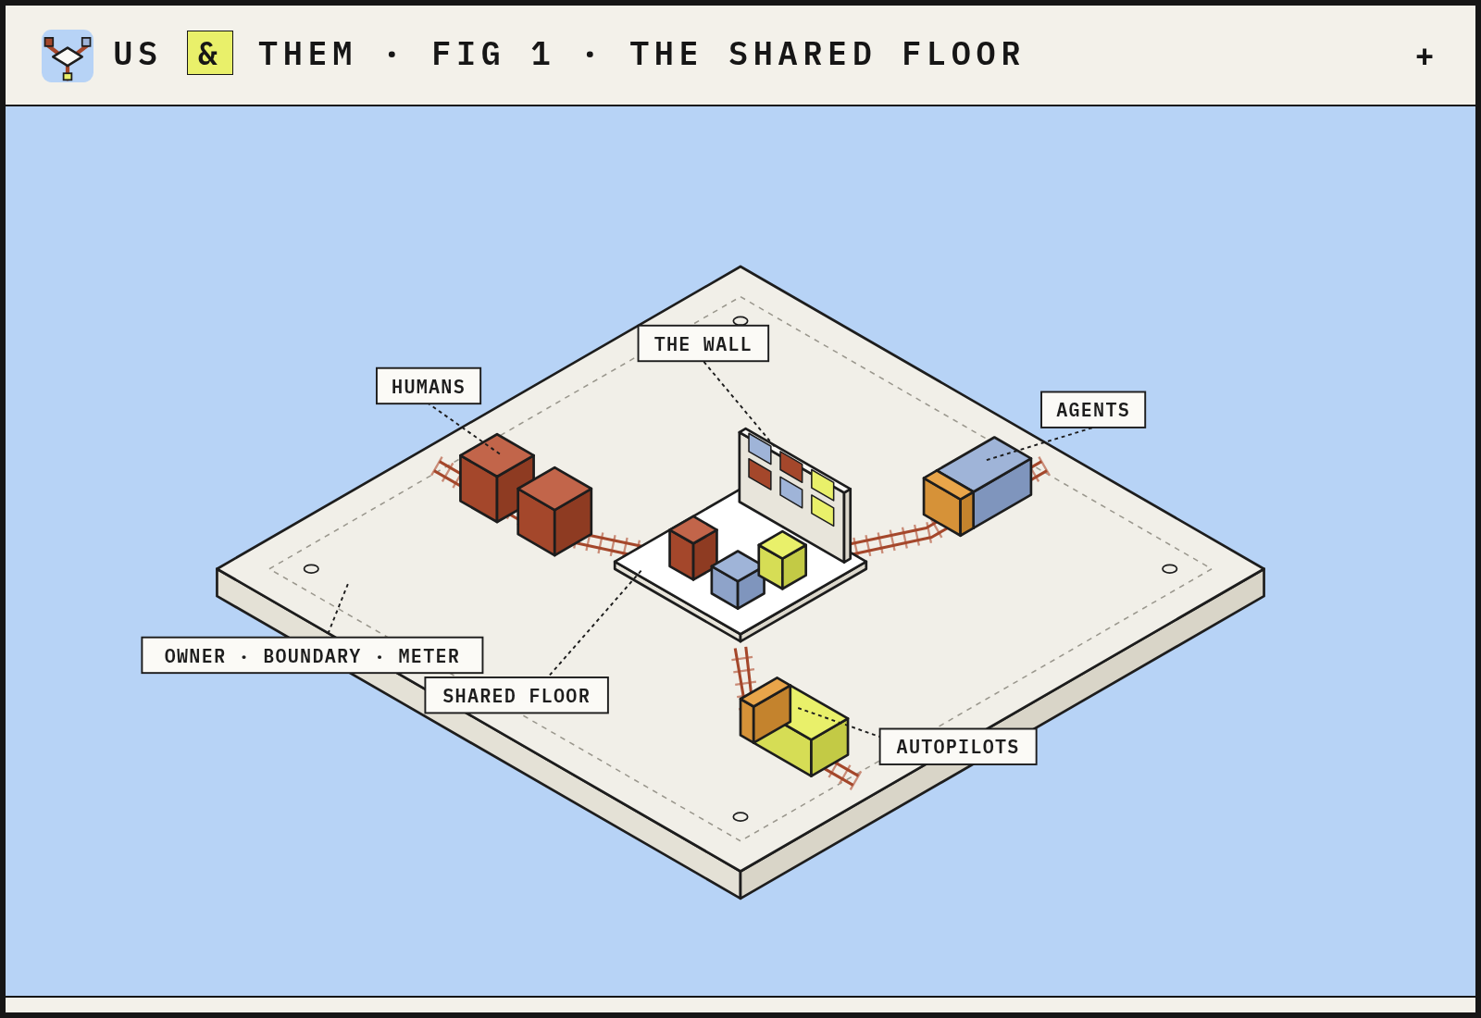
FIG 1 ON A BOARD · FRAMEVR/ASSETS/BOARD-FIG1.PNG
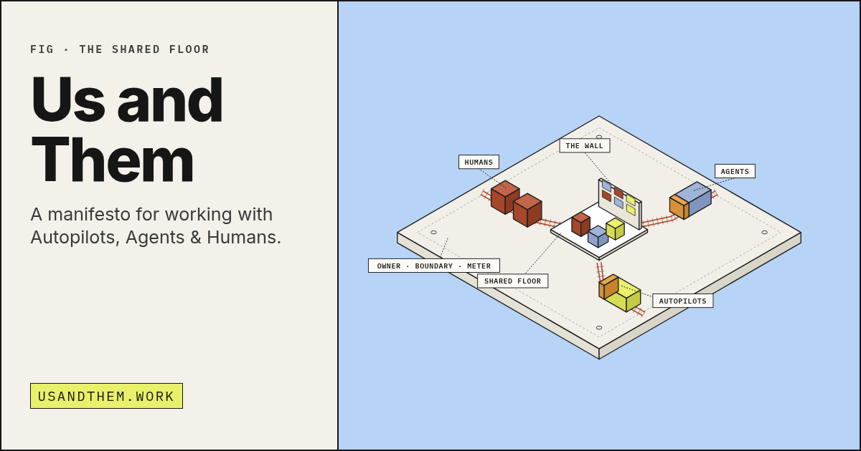
SOCIAL CARD · SITE/OG.PNG · 1200 × 630

10 · FRAMEVR

FrameVR boards and areas
In FrameVR, boards follow the same rules: paper boards with ink type, sky panels for diagrams, one highlighter tag per board.
The Us and Them space is a set of named areas in the forza frame, all prefixed usandthem (entry: framevr.io/forza#usandthem). Conference-2 is a separate build and is never touched.
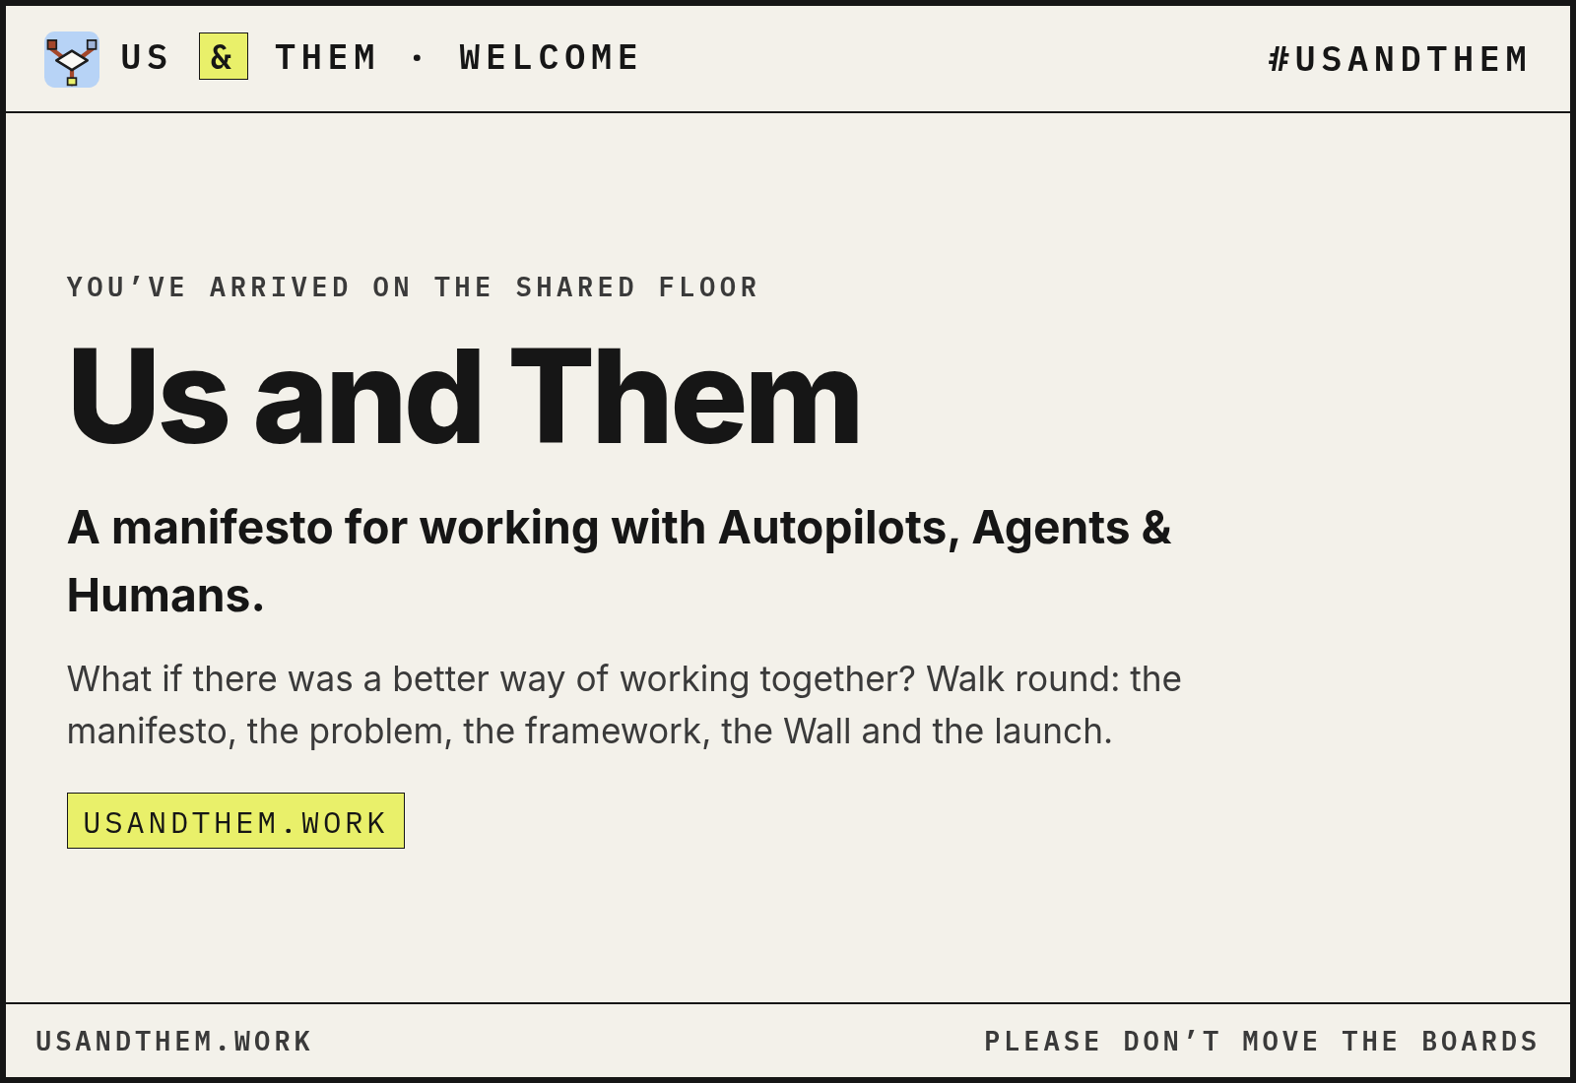
WELCOME BOARD · 1600 × 1100

Board anatomy (as built in tools/render_boards.py)
PART | SPEC
Frame | 6 px ink border on paper
Top bar | Logo mark + US & THEM · <TITLE> left; #USANDTHEM-<AREA> right; mono caps 0.16em; 2 px rule below
Accent strip | 14 px under the bar on area boards: sky (Microsoft areas), highlighter (System 1), rust (System 2)
Body | Eyebrow, Inter 800 heading, Inter body in ink 2
Footer bar | USANDTHEM.WORK left; area URL or a dry line (PLEASE DON’T MOVE THE BOARDS) right; 2 px rule above
Sizes | 1600 × 1100 standard; 1600 × 1300 manifesto; 2400 × 600 banner
Legibility | Text at least 60 pt equivalent, ink on paper
Assets | Grab-locked and tagged managed-by-builder, usandthem
Platform text boards | Frame text areas use Poppins (a Frame limitation); image boards use Inter + Plex Mono

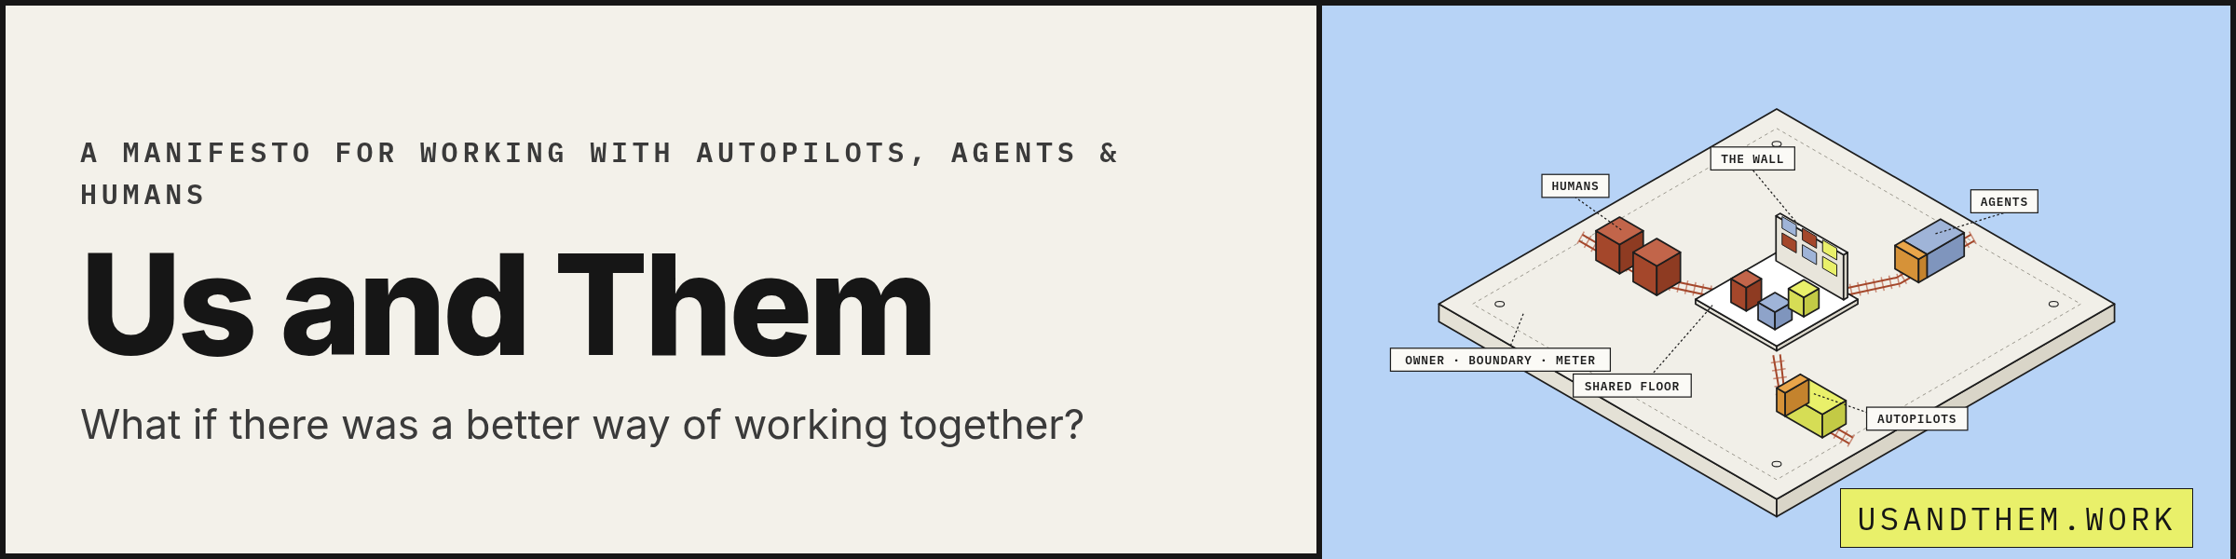
WORDMARK BANNER · 2400 × 600
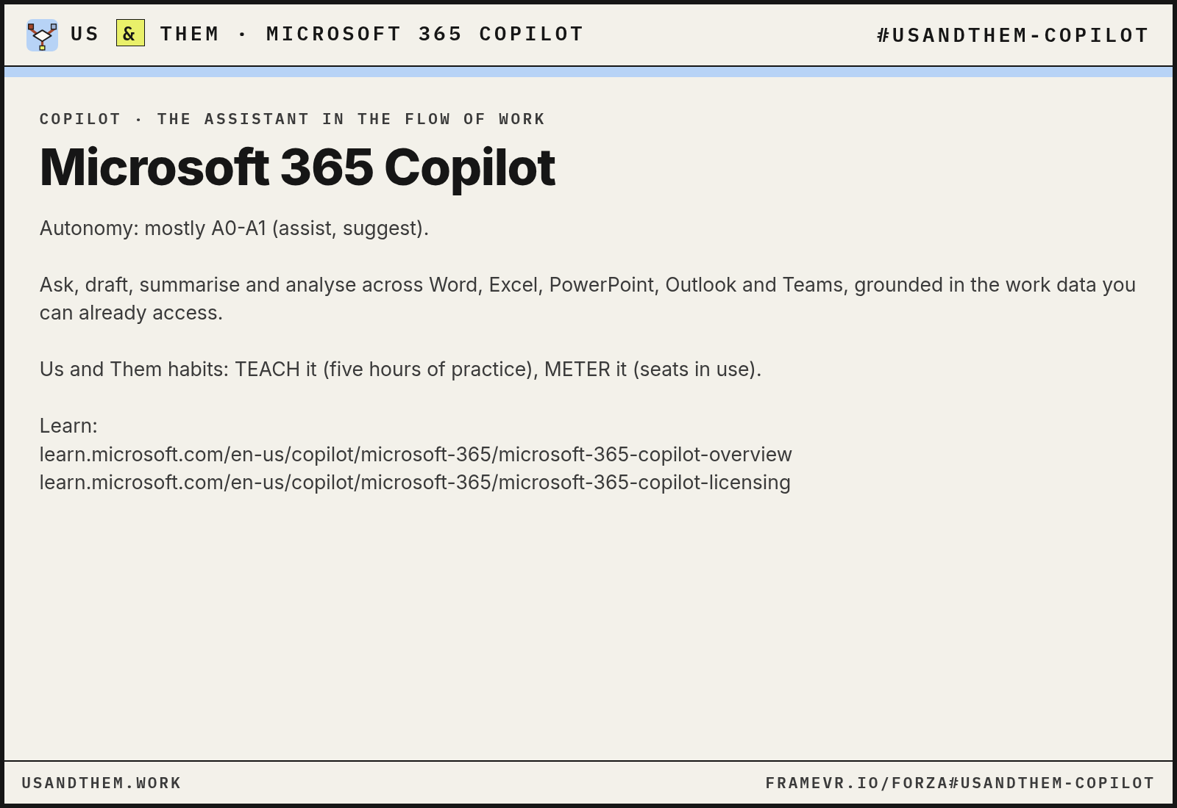
AREA BOARD · SKY ACCENT STRIP
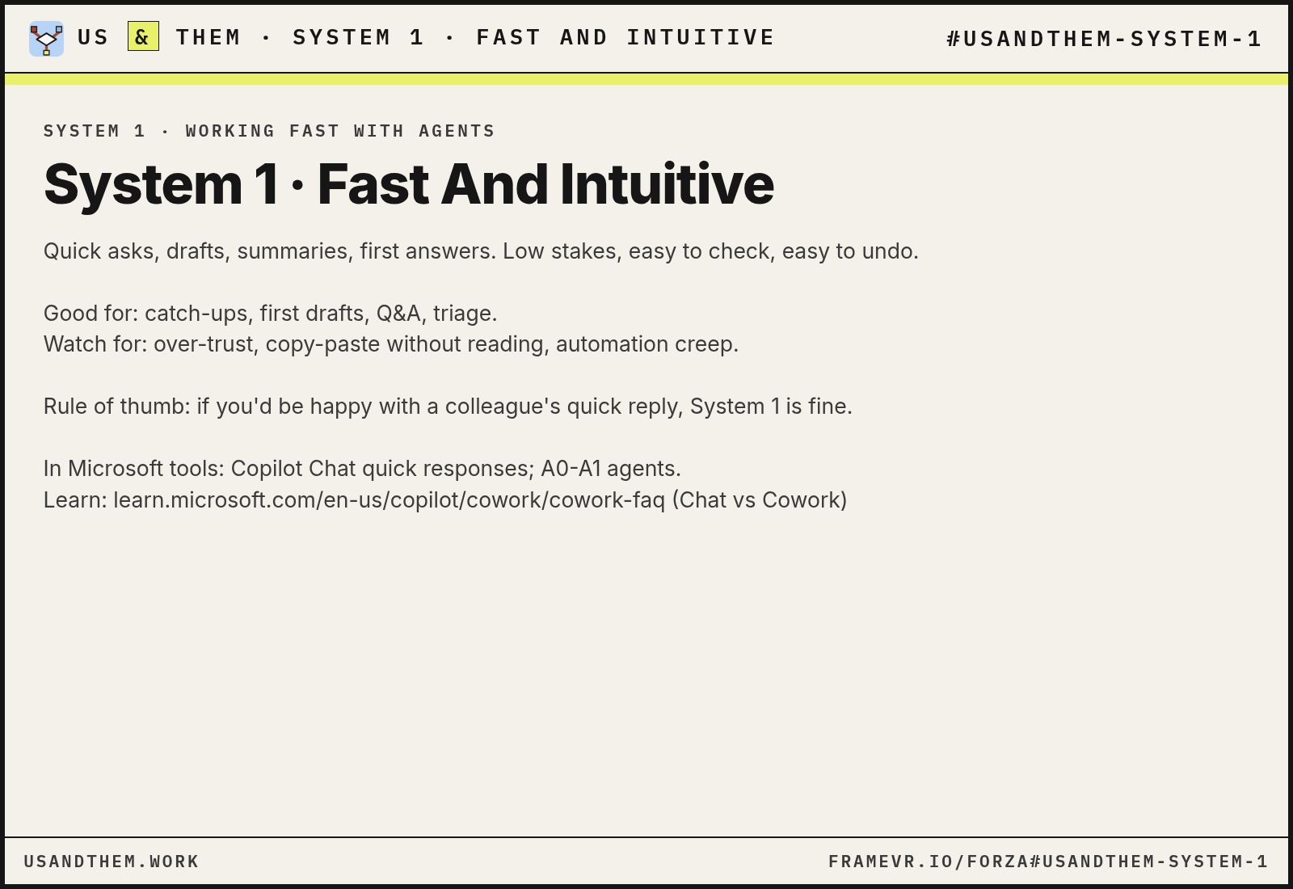
AREA BOARD · SYSTEM 1 · HIGHLIGHTER STRIP
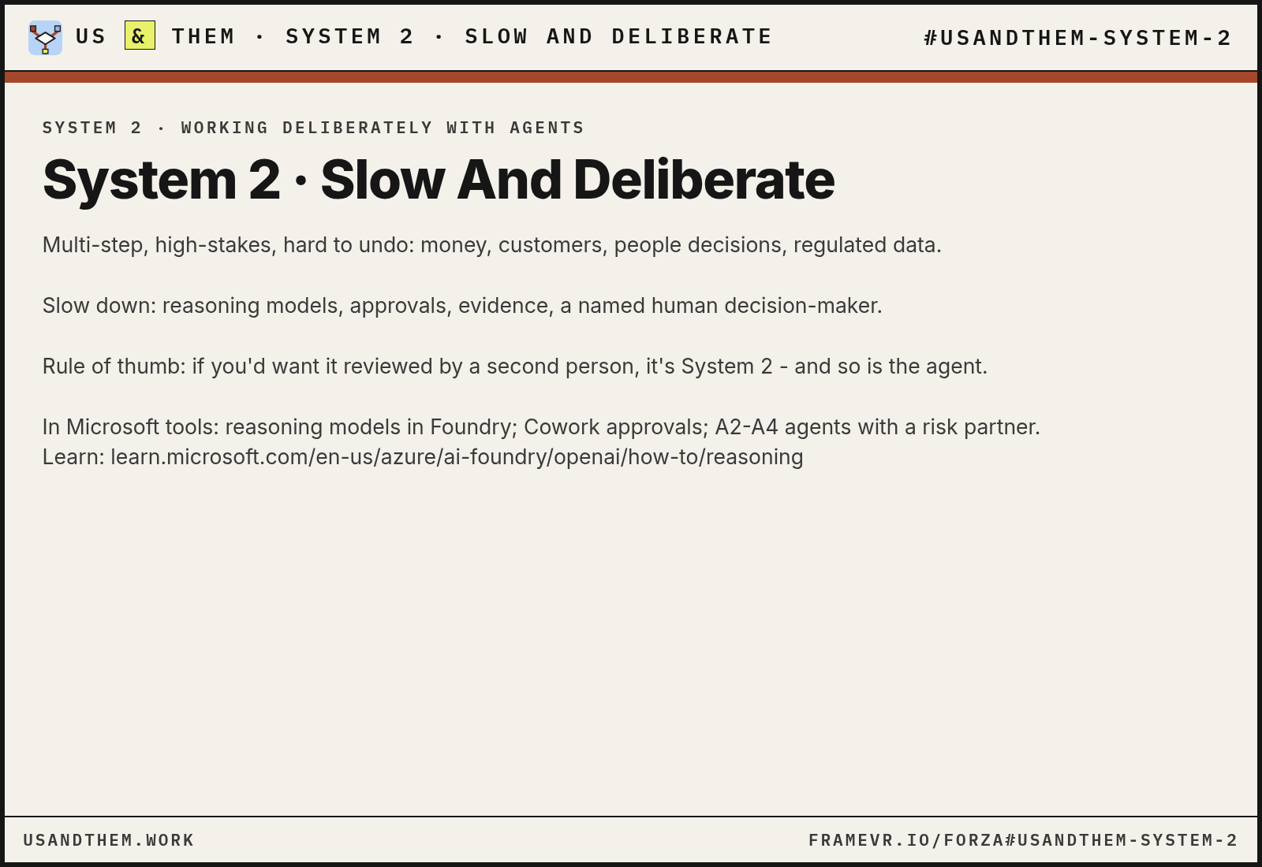
AREA BOARD · SYSTEM 2 · RUST STRIP
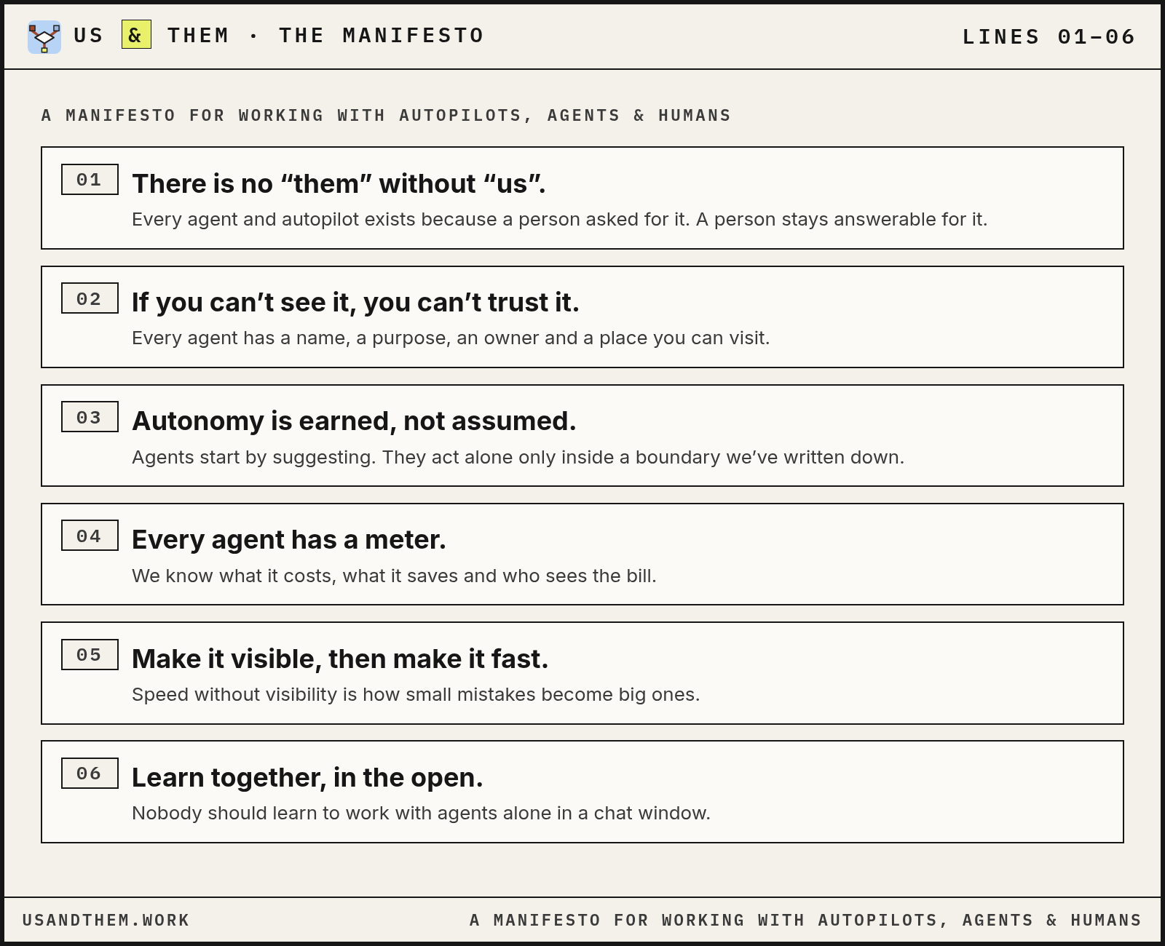
MANIFESTO BOARD 1 OF 2 · 1600 × 1300
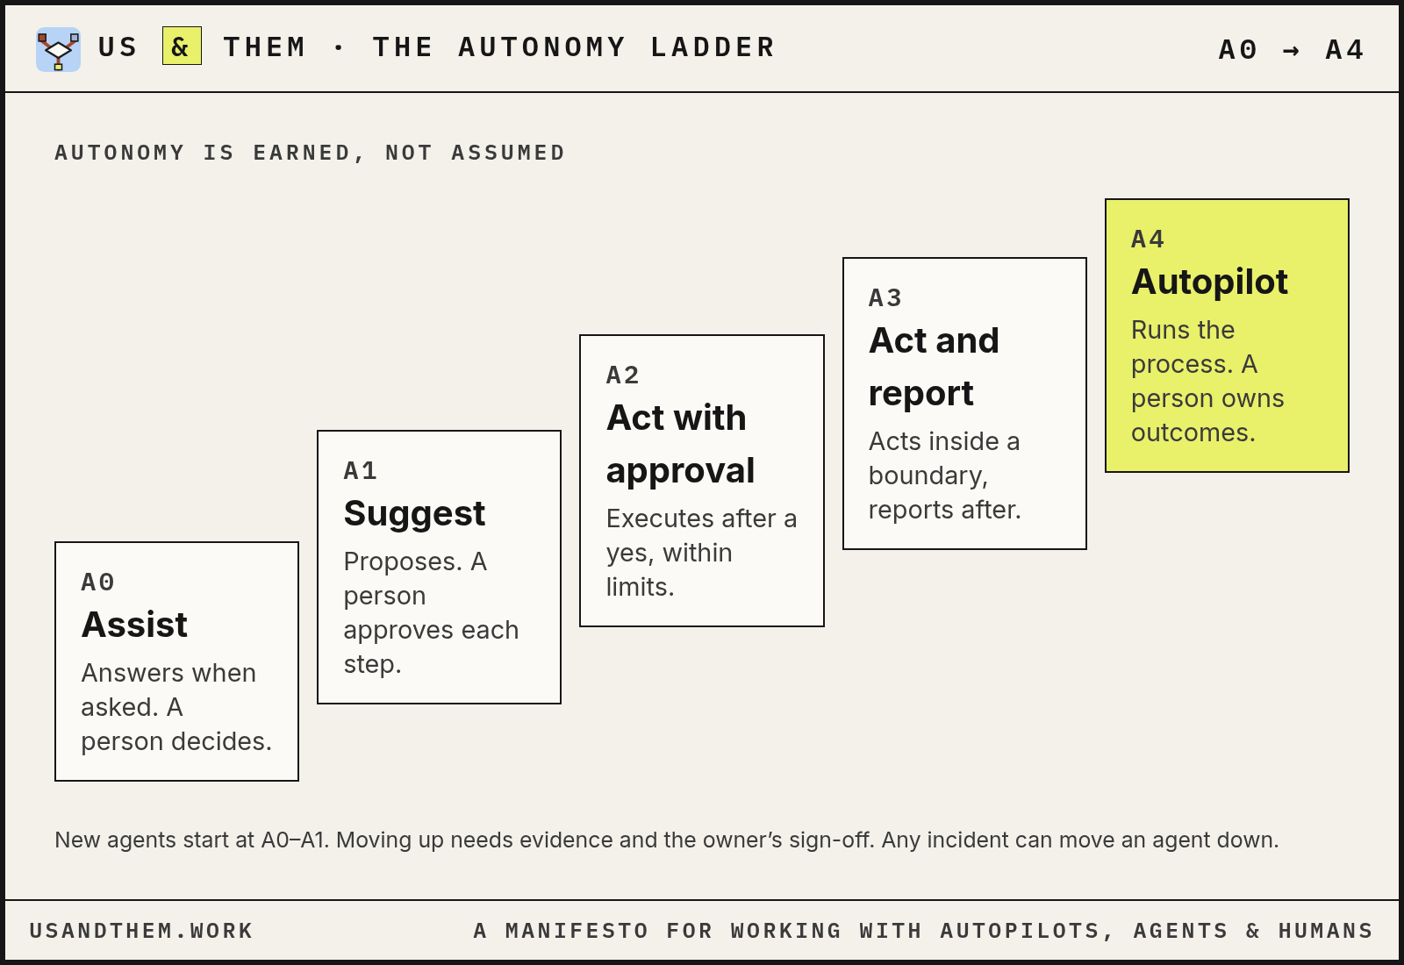
AUTONOMY LADDER BOARD
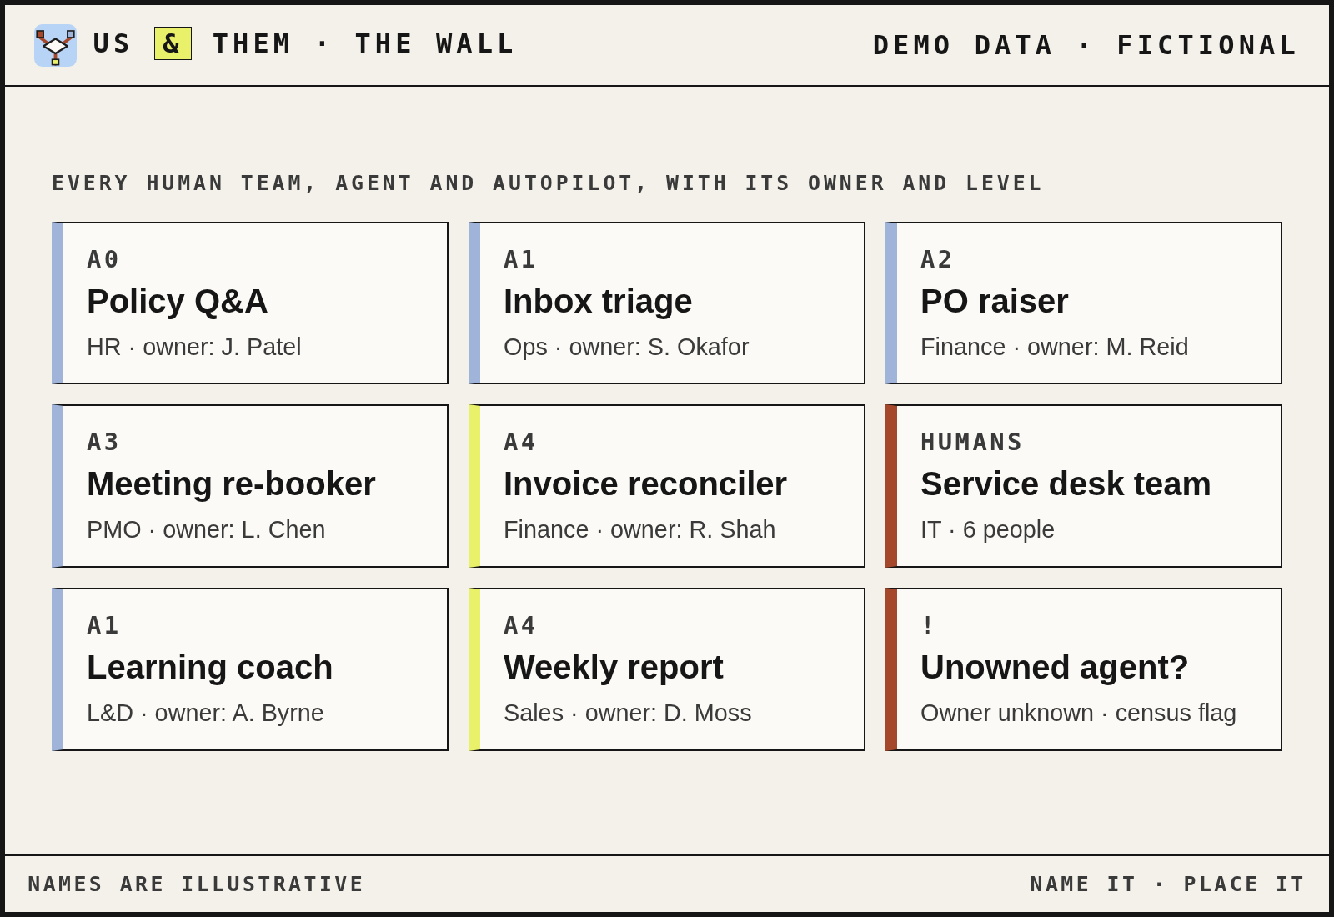
THE WALL · ONE CARD PER TEAM, AGENT AND AUTOPILOT
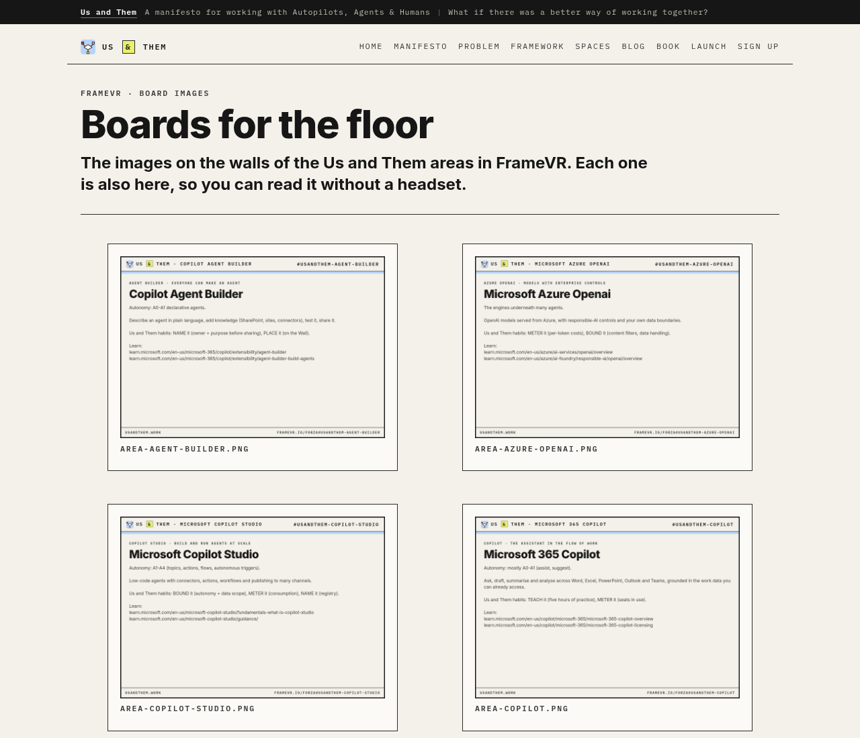
ALL BOARDS ARE ALSO PUBLISHED AT /FRAMEVR/

11 · VOICE

Voice and tone
A practical colleague who has done this before, explains it plainly, and is a bit dry about the hype.
Curious, never alarmist. Plain speaking. UK spelling. We write as “we”, never as a named person. Faceless for now: no personal names or bylines on public surfaces.
WE ARE | WE AREN'T
Plain: “agents need an owner” | Jargon: “operationalise agentic accountability frameworks”
Honest: “we don’t know yet” | Certain about the future
Hopeful and practical | Doom-laden or utopian
Specific: “15 minutes, weekly, in the team zone” | Vague: “regular touchpoints”
Sourced: every number linked | “Studies show…”
Inclusive: “us” means everyone at work | “Users”, “resources”, “headcount”

Words
WORDS WE USE | WORDS WE AVOID
people, teams, agents, autopilots, the floor, owner, boundary, meter, show and tell, retire | synergy, unleash, revolutionise, game-changer, digital workforce (unless quoting), the robots are coming

Preferred swaps (elaboration)
INSTEAD OF | WRITE
users | people
resources | people / teams
headcount | people
regular touchpoints | a named ritual with a time, e.g. “15 minutes, weekly, in the team zone”
studies show | name and link the source
operationalise | do / run / set up
digital workforce | agents and autopilots
robot / bot army | agents

Writing rules
- Sentences under 25 words where possible. Short paragraphs.
- Lead with the point. Then the reason. Then the example.
- One idea per heading.
- Numbers: figures for 10 and above, words below, except in tables.
- Currency as £ for UK offers, USD where the source uses it.
- Dates as “22 April 2027”. Times with a zone, e.g. “13:00 BST”.
- UK spelling throughout (organisation, colour, licence as a noun, programme).
- In running text write “Us and Them”; the ampersand only in the wordmark and in “Autopilots, Agents & Humans”.

The citation rule
Sourced, always. Every number links to its source (docs/sources.md, S1–S19). Never invent, extrapolate or round up a statistic. If there is no source, label it OUR VIEW or leave it out.

EXAMPLES

Do and don't: sample copy
DO | DON'T
Every agent needs an owner. No owner, no launch. | Organisations must operationalise agentic accountability frameworks to unleash value.
We don’t know yet how far A4 will go. Here’s what we’ve seen so far. | By 2030 the robots are coming for every job.
Floor walk: 15 minutes, weekly, in the team zone. | Regular touchpoints to drive synergy.
IBM found 63% of breached organisations had no AI governance policy or were still writing one [S2]. | Studies show most companies have no AI policy.
Count your agents. You’ll be surprised. | Revolutionise your digital workforce with this game-changer.
People, teams, agents and autopilots. | Users, resources and headcount.

Sample copy by format (elaboration)
FORMAT | SAMPLE
Hero | Us and Them. Agents are arriving faster than we can see them, pay for them, or learn to work with them.
Eyebrow + H2 | HABIT 03 · BOUND IT — What may it do on its own?
Button | READ THE MANIFESTO → · SIGN UP
Highlighter tag | LAUNCH · THURSDAY 22 APRIL 2027
Board footer | PLEASE DON’T MOVE THE BOARDS
Social post | Week 3: count your agents. An afternoon census, five steps, and what usually turns up. usandthem.work
Email subject | Who owns this agent?

12 · ACCESSIBILITY

Accessibility and contrast
FOREGROUND | BACKGROUND | RATIO | WCAG | USE
ink | paper | 16.0:1 | AAA | Default text
ink-2 | paper | 10.1:1 | AAA | Secondary text
muted | paper | 4.8:1 | AA | Captions and meta at 12 px and above only
rust | paper | 5.3:1 | AA | Emphasis, links, focus ring
ink | sky | 11.8:1 | AAA | Labels on diagram panels
ink | hl | 14.8:1 | AAA | Highlighter tags
#ffffff | rust | 6.0:1 | AA | White text on rust
paper | ink | 16.0:1 | AAA | Byline bar, wordmark on dark
ink | card | 17.3:1 | AAA | Cards and buttons

Ratios recalculated on 31 October 2026 with the WCAG relative-luminance formula; they match the v0.1 guide. Ink on card (17.3:1) and paper on ink (16.0:1) are added.
- Body text 16 px minimum.
- Muted text for captions at 12 px and above only.
- Visible focus ring: 3 px rust outline with 2 px offset.
- Every diagram has an aria-label or a text description next to it.
- Respect prefers-reduced-motion.
- Pages are lang="en-GB" with a Skip to content link.
- Never put text on amber or agent blue at small sizes.
- In FrameVR, board text at least 60 pt equivalent and high contrast (ink on paper).
13 · FILES

Files and naming
FILE | PURPOSE
site/styles.css | Design tokens and components (source of truth for web)
site/favicon.svg | Logo mark
site/assets/logo-mark.svg | Logo mark
site/assets/hero-floor.svg | FIG 1 hero illustration
site/og.png | Social card 1200×630
framevr/assets/*.png | Banners and boards for FrameVR
docs/brand/usandthem-brand.json | Design tokens and rules (machine-readable)
docs/brand/usandthem-brand-guidelines.docx | This document
docs/brand/usandthem-brand-system-prompt.md | System prompt for AI assistants
docs/brand/img/*.png | Images in this document (tools/brand_assets.py)

Naming (elaboration from existing files)
TYPE | PATTERN | EXAMPLE
Board | board-<topic>.png | board-welcome.png
Area board | area-<area-slug>.png | area-copilot-studio.png
Banner | banner-<name>.png | banner-wordmark.png
Doc | docs/NN-<topic>.md | docs/03-website.md
Blog post | blog/<slug>.html | blog/count-your-agents.html
Brand file | usandthem-brand-<form>.<ext> | usandthem-brand-system-prompt.md

- Lower-case kebab-case, no spaces, no dates in file names (dates go in the document).
- Area slugs match the FrameVR spot names without the usandthem- prefix.

14 · EXAMPLES

Examples in use
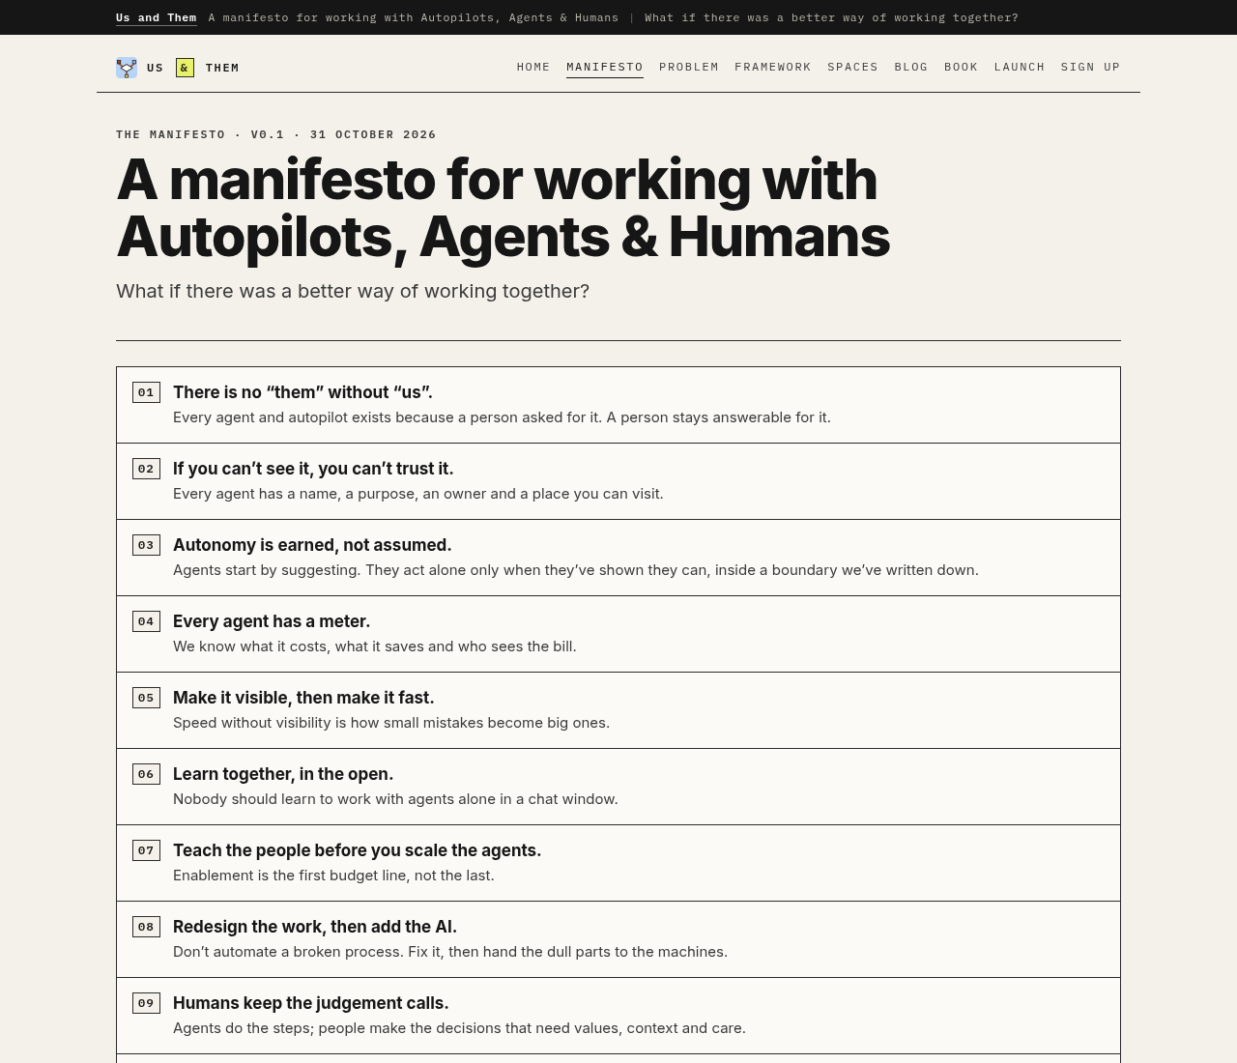
MANIFESTO PAGE · NUMBERED LIST, EYEBROWS, ONE COLUMN MEASURE
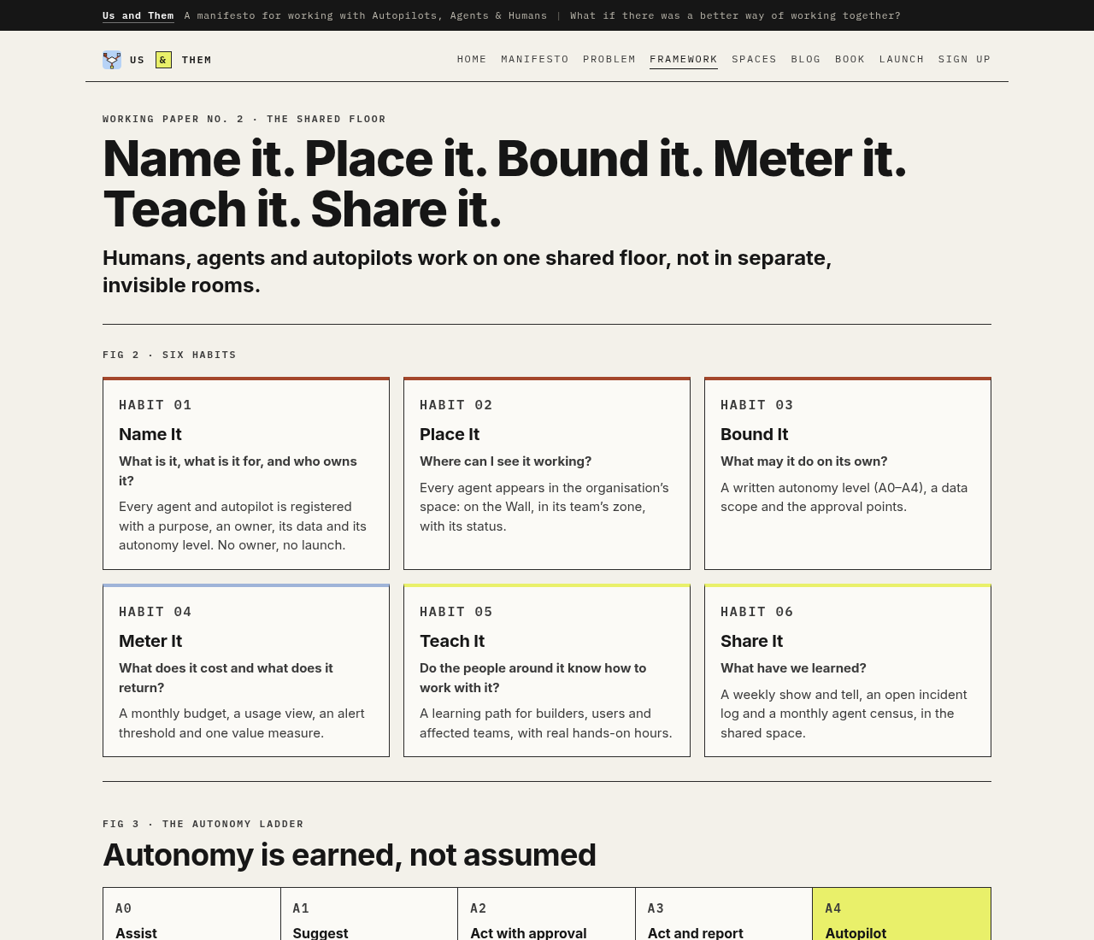
FRAMEWORK PAGE · HABIT CARDS WITH TOP RULES, AUTONOMY LADDER
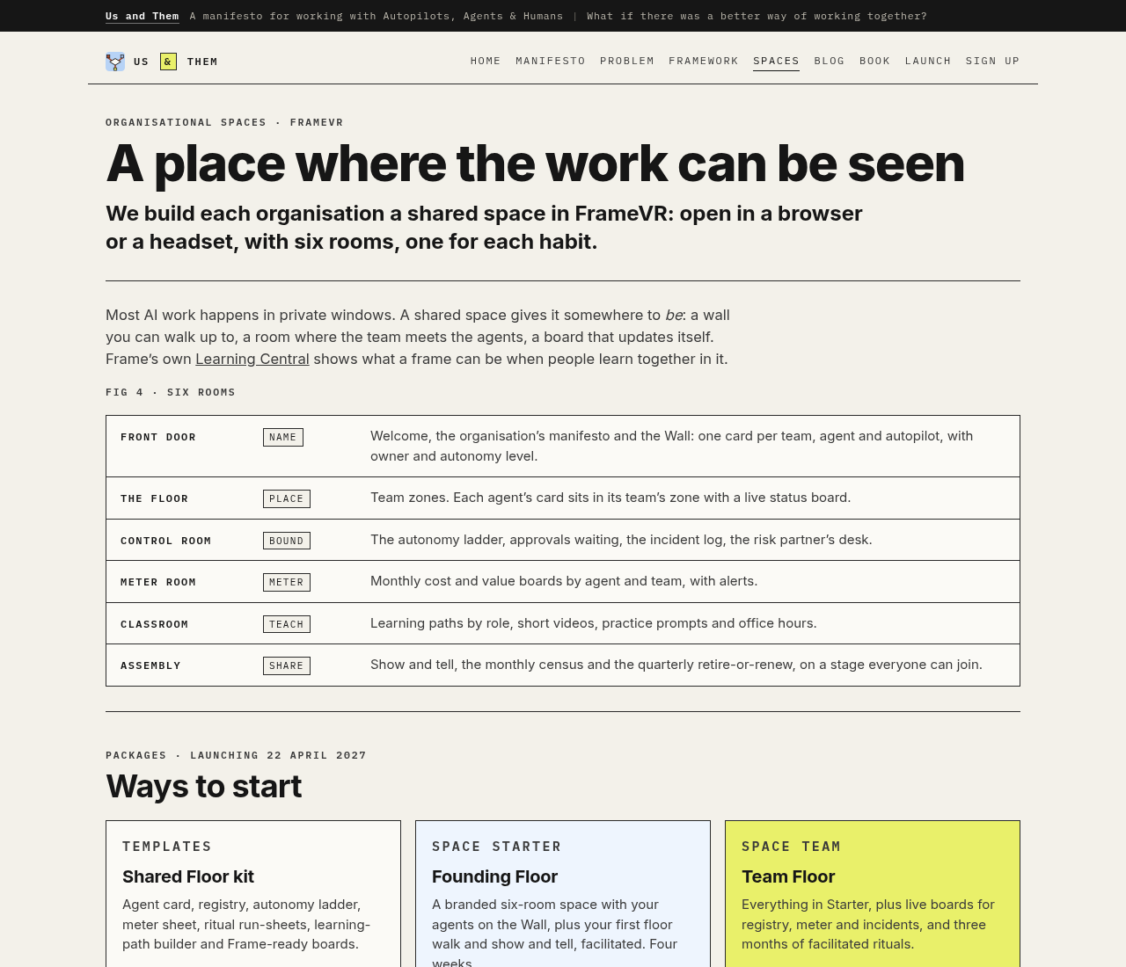
SPACES PAGE · ROOMS LIST AND AREA CARDS
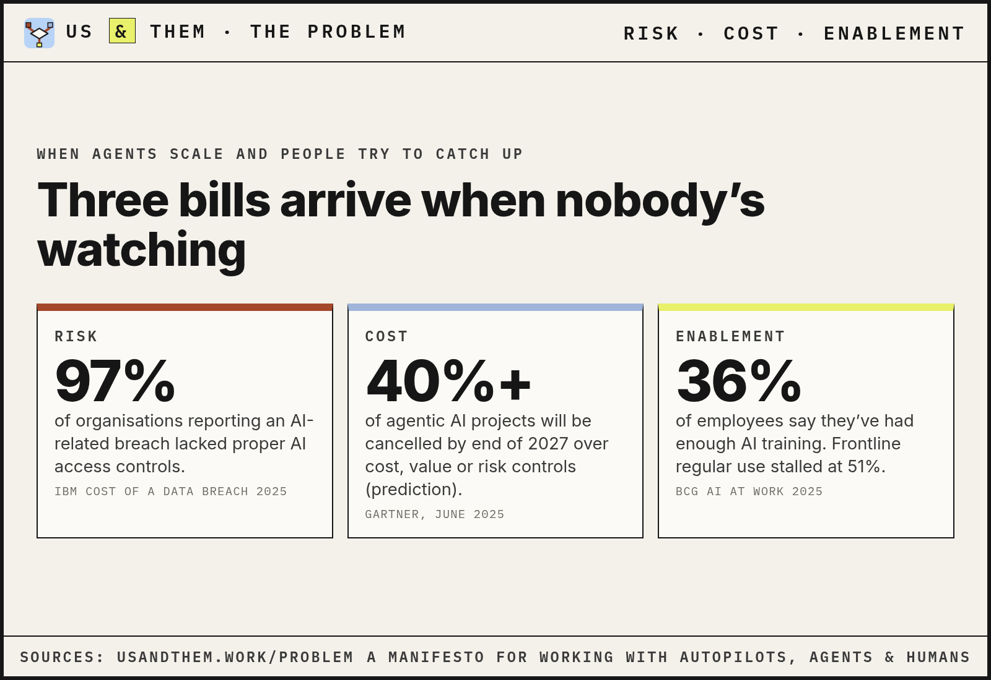
PROBLEM BOARD · RISK, COST, ENABLEMENT
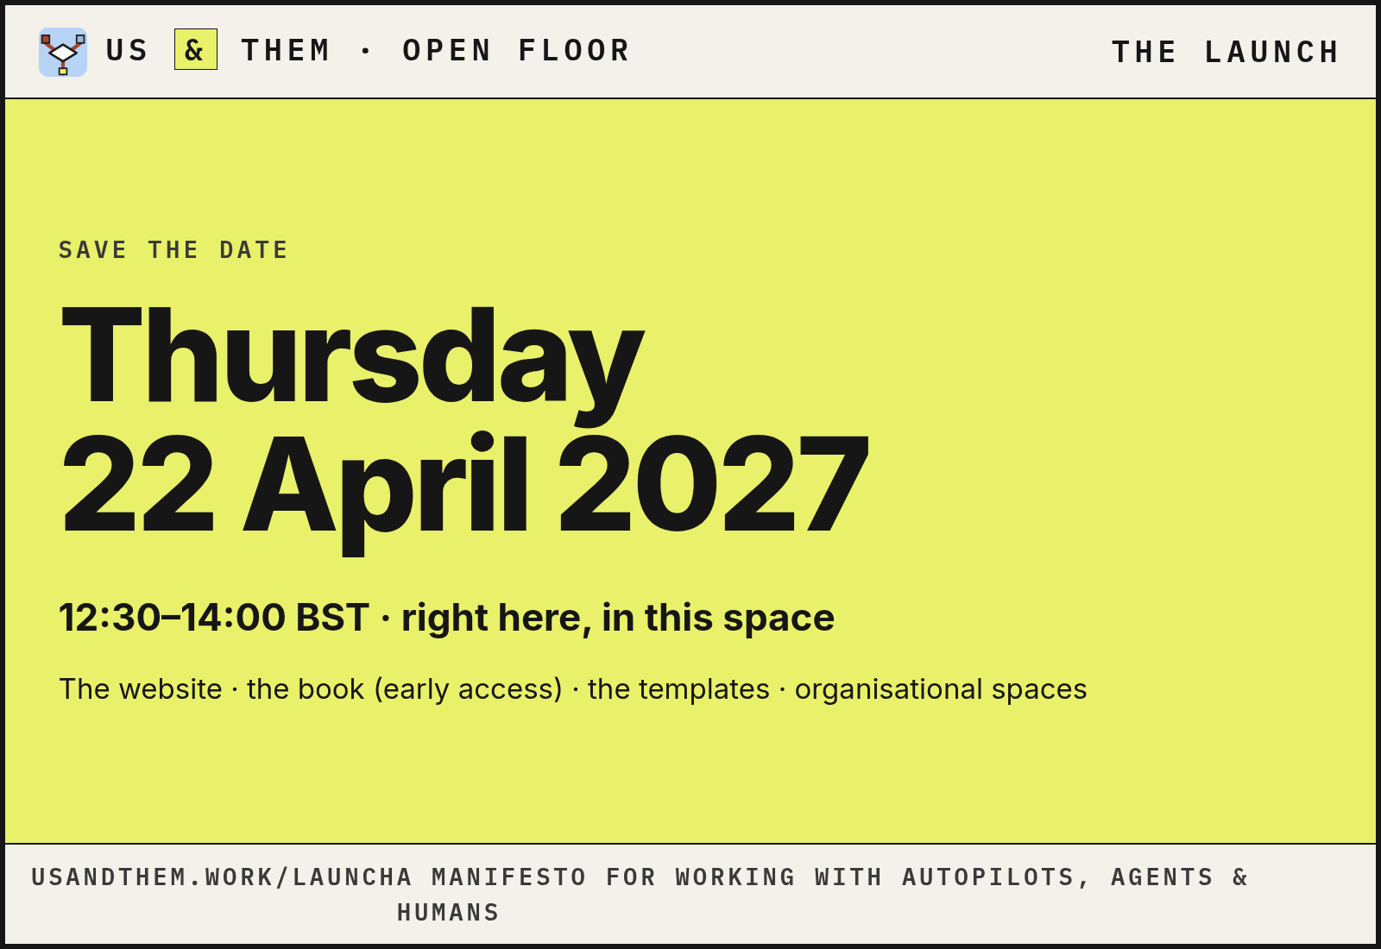
LAUNCH BOARD · THE ONE HIGHLIGHTER TAG IS THE DATE

15 · NOTES

Elaborations and open questions
These go beyond the v0.1 guide. They describe or extend what is already built; none adds a new colour, font or mark.
- Preferred-term swaps (e.g. users → people) are derived from the guide's “We aren't” column; the guide lists the banned words but not every replacement.
- Spacing scale is read from site/styles.css values in use (4–44 px); the v0.1 guide does not define a named spacing scale.
- Radius tokens: 0 for all UI. The logo mark's 6/32 rounded square is the only radius, as built in favicon.svg.
- Board conventions (bar, footer, accent strip, 6 px frame, 1600×1100 px) are documented from tools/render_boards.py, not from the v0.1 guide.
- Sample copy and example outputs are written for this document in the guide's voice; they are not published brand lines.
- File-naming convention generalises the names already used in the repo (kebab-case, prefix by type).
- The ⌖ crosshair glyph used in figure headers is not in Inter or IBM Plex Mono, so it falls back to a system font and can show as a box on some systems; the guidelines images draw it as a small SVG. Recommendation only: swap the glyph for an inline SVG on the site.
- The FrameVR intro boards created by the API use Frame's Poppins text-area font (framevr/build_areas.py), not Inter. Treat this as a platform limitation; image boards use Inter and IBM Plex Mono.

Open brand questions
- Name clearance: “Us and Them” is also the title of a 1973 Pink Floyd song and other works. Check UK IPO / EUIPO marks in classes 41 and 42 before printing.
- Byline: faceless for now. The bar carries “Us and Them” and the strapline; revisit if a named author is wanted later.
- Manifesto licence: CC BY 4.0 suggested, not yet confirmed.
US & THEM · USANDTHEM.WORK · A SIBLING OF TROLLEYPROBLEMS.WORK

